**Dissociating Working Memory and Inhibition:**

**An Effect of Inhibitory Load in Children while keeping Working Memory Load Constant**

**Andy Wright1 and Adele Diamond1,2**

**1 Department of Psychiatry, University of British Columbia,**

**and 2 BC Children’s Hospital, Vancouver, BC Canada**

**address correspondence to:**

Prof. Adele Diamond

Department of Psychiatry

UBC

2255 Wesbrook Mall

Vancouver, BC Canada V6T 2A1

email: adele.diamond@ubc.ca

phone: 604 822 7220

fax: 604 822 7232

**Dissociating Working Memory and Inhibition:**

**An Effect of Inhibitory Load in Children while keeping Working Memory Load Constant**

**Abstract**

People are slower and more error-prone when the correct response is away from a stimulus (incongruent) than when it’s towards a stimulus (congruent). Two reasons for this are possible. It could be caused by the requirement to inhibit the prepotent tendency to respond toward a stimulus, or by the order of task presentation causing difficulty switching from one rule to another. This experiment (with 96 children 4-10 years old) used the hearts and flowers task to differentiate between these two possibilities by counterbalancing order of task presentation. Half the children were presented with the congruent block first (the traditional order for the task) and half with incongruent trials first. The results, which were the same regardless of task order, seem to clearly show that the increased inhibitory control demand is responsible for children’s decreased accuracy and slower responses in the incongruent block. Worse performance on incongruent trials when they came first cannot be accounted for by working memory or task-switching accounts. Since working memory demands are no greater on the incongruent block when it’s presented first than on the congruent block, yet performance was worse, results here indicate that inhibition and working memory can be dissociated and that increasing inhibitory demands alone is sufficient to impair children’s performance.

**Introduction**

It is hotly debated whether working memory and inhibitory control are separable or not. Many argue that working memory is all that is required; one need not posit a separate inhibitory control ability (Chatham, Claus, Kim, Curran, & Banich, 2012; Cohen, Braver, & Brown, 2002; Egner & Hirsch, 2005; Hanania & Smith, 2010; Nieuwenhuis & Yeung, 2005; Munakata et al., 2011). Others posit that inhibitory control is an ability in its own right, separate from working memory (e.g. Diamond, 2009; Gazzaley, Cooney, Rissman, & D'Esposito, 2005; Gernsbacher, 1993; Leroux et al., 2006; Levy & Anderson, 2002; Zanto & Gazzaley, 2009).

When performing tasks that require working memory and inhibitory control, people are slower and make more errors on incongruent blocks than on congruent ones. Each block may have only one rule but incongruent blocks add an inhibitory demand. When the incongruent block follows a congruent one, poorer performance on the incongruent block could easily be due to problems in efficiently clearing the congruent rule from working memory. Thus the working memory demand might be greater on Block 2 than on Block 1. However, when the incongruent block is presented first as Block 1, the same explanation cannot account for poorer performance on the incongruent block. Worse performance on the incongruent block compared to the congruent block when the incongruent block comes first can only be attributed to the greater inhibitory demand in the incongruent block. It would seem to provide evidence in favor of working memory and inhibitory control being separate.

In the standard Hearts and Flowers task (previously called the Dots task; Davidson, Amso, Anderson, & Diamond, 2006; Diamond, Barnett, Thomas, & Munro, 2007) participants are instructed to press the response button on the same side (left or right) as the stimulus (a red heart) on Block 1 (the congruent block), to press the response button on the side opposite the stimulus (a red flower) on Block 2 (the incongruent block), and to flexibly switch between those two rules on Block 3 where the stimulus might be a heart or flower (the mixed block). Participants of every age tested (4 – 13 years, plus adults) are slower and make more errors on the mixed block. Adults, however, are as fast and as accurate on the incongruent block as they are on the congruent one. In contrast, children of all ages tested (4-13 years) are slower and make more errors on the incongruent block than on the congruent one (Davidson et al., 2006). This paper explores why. What is the critical difference between the incongruent and congruent blocks that causes the increased difficulty for children? We investigated two competing hypotheses:

(1) Children might err on the incongruent block because of the addition of an inhibitory demand – the need to resist responding on the same side as the stimulus, responding on the opposite side instead. People have a prepotent tendency to respond toward a stimulus (Simon & Rudell, 1967; Fitts & Seger, 1953; Hommel, 2011; Hommel, Proctor, & Vu, 2004; Lu & Proctor, 1995). That must be inhibited when the stimulus and its associated response are on opposite sides (incongruent trials). Indeed, when monkeys are to respond away from a visual stimulus, the neuronal population vector in primary motor cortex (coding the direction of planned movement) initially points toward the stimulus and only then shifts to the required direction (showing a prepotent tendency at the neuronal level to respond toward a stimulus; to do otherwise requires that that impulse be inhibited; (Georgopoulos, 1994; Georgopoulos, Lurito, Petrides, Schwartz, & Massey, 1989). This can be seen in the brain activity of humans as well using lateralized motor-readiness evoked potentials (Valle-Inclan, 1996).Thus, adults and children tend to be slower and make more errors when the stimulus appears on the side opposite its associated response than when the required response is on the same side as the stimulus (called the Simon Effect, spatial incompatibility, or stimulus-response incompatibility; (***adults***: Hommel, 2011; Hommel, Proctor, & Vu, 2004; Kunde & Stocker, 2002; Lu & Proctor, 1995; Simon R. J., 1990 ***children***: Gerardi-Coulton, 2000; Davidson et al., 2006; Mullane, Corkum, Klein, & McLaughlin, 2009).

In the Hearts and Flowers task, Blocks 1 and 2 have the same memory requirement (each block has only one rule, either: ‘Respond on the same side as the stimuli or ‘Respond on the side opposite the stimulus.’) Both blocks require *working* memory because we do not have ‘same side’ or ‘opposite side’ hands (we have right and left hands) so on each trial these rules must be translated into which hand to use (requiring that we mentally work with the rule held in mind). The two Blocks differ, however, in their inhibitory demand. For the congruent block one need only do what comes naturally, but for the incongruent block one must inhibit that and do the opposite. Thus, one hypothesis about why children might make more errors and take more time to respond on the incongruent block is because of their immature ability to exercise inhibitory control.

(2) Perhaps it is the task switching requirement that gives children difficulty. The incongruent block always follows the congruent one on the standard Hearts and Flowers (aka Dots) task. Perhaps it is their difficulty switching from the rule to always press on the same side as the stimulus to the rule of always pressing on the side opposite that accounts for slower response times and more errors on Block 2 (the incongruent block). We know that switching from one rule to another can be difficult even for adults, and especially for children (Cepeda, Kramer, & Gonzalez, 2001; Crone, Bunge, & Van Der Molen, 2006; Monsell & Driver, 2000; Yeung, Nystrom, Aronson, & Cohen, 2006; Zelazo, Muller, Frye, & Marcovitch, 2003).

It may be that children do not wipe their mental slate clean when they begin Block 2, and so are still holding the now irrelevant rule from Block 1 in mind. That would mean that the memory load for them on Block 2 would be greater because they would be holding in mind both the congruent and incongruent rules. If that is the case, then reversing the order in which the congruent and incongruent blocks are presented should get rid of poorer performance on the incongruent block.

In a between-subjects design we tested half the children at each age (6 – 10 years) with the congruent block first and half with the incongruent block first on the Hearts and Flowers task.

**Methods**

**Participants**

Data were obtained from 96 children, ranging in age from 6 to 10 years (50% male, 50% female; see Table 1), from 13 different public elementary schools throughout the Lower Mainland of British Columbia, Canada. Participants were recruited through their schools and 95%were tested at their school. The other 5 children were tested at our child development lab at the University of British Columbia. Insert Table 1 about here

The majority of participants who provided ethnic information were Caucasian of European descent (52%), 16% were of East Asian descent (mostly Chinese), 12% were of South Asian descent (most were Indian), and the rest were of other ethnic backgrounds. All were fluent in English. Informed consent was obtained from the parents of all children before testing. All participants received a small present for their participation.

**Procedure**

Within each age X gender grouping, half the participants were randomly assigned to get the congruent block first and half to get the incongruent block first. Participants were tested individually in a quiet room while wearing noise cancellation headphones. The stimuli were presented on a Dell 43cm touchscreen monitor, attached to an IBM ThinkPad Lenovo T6 laptop computer. The Hearts and Flowers task was administered experiment using Presentation® software.

Participants held a handlebar with both hands to keep the distance from their hands to the response buttons constant. They were instructed to use only their pointer finger to press the response box on the screen (see Fig. 1). All participants completed a button practice task before moving onto Hearts and Flowers to get them acclimated to using the handlebars and to pressing the left and right response boxes on screen

-------------------------------

Insert Figure 1 about here

-------------------------------

Two response buttons appeared on the touchscreen monitor and for the practice task children were to press a response button when a smiley face appeared on it. Children were corrected if they reached across the midline to respond. They were also corrected if they left their finger on the monitor after their response, did not keep their hands on the handlebars before the smiley face disappeared, or did not replace their finger on the handlebars after pushing the button.

On each trial of the Hearts and Flowers task, a red heart or a red flower appeared on either the left or right side of the screen. A correct response to the heart was to press the response box on the touchscreen monitor on the same side as the heart. A correct response to the flower was to press the response box on the side opposite the flower.

On each trial, a horizontal rectangle (6c m x 18 cm) was presented in the centre of the screen. An orienting crosshair was presented for 500 ms at center fixation at the outset of each trial, and then disappeared, being replaced 500 ms later by a stimulus on the left or right. One stimulus was presented per trial. The stimulus was presented for 750 ms to children ≥7 years of age and for 1500 ms to children 6 years of age. (These timing parameters had been determined to be appropriate by Davidson et al. 2006.) Each test block was preceded by instructions and a demonstration of the task followed by a practice block. Understanding of the rule was demonstrated by getting at least 3 of the 4 trials correct in the practice block. If understanding was not demonstrated on the first practice block, the child was instructed again and given another practice block (2 children in the incongruent-first condition, 2 in the congruent-first condition). No participant in this study failed to pass the practice. The congruent and incongruent test blocks consisted of 12 trials each. Trials in each block were presented in the same pseudo random order to each child.

**Results**

The two dependent measures were speed (reaction time [RT]) and accuracy (percentage of correct responses). Trials with RTs faster than 250 ms were excluded for being too fast to have been in response to the stimulus (resulted in 5 trials being excluded). RTs 2 standard deviations above or below the mean were also excluded from analyses because they were outliers (3 trials excluded). Percentage of correct responses was calculated by dividing the correct responses by the total number of responses (excluding the aforementioned two exceptions). Only correct trials were used in calculating a child’s mean RT in a test block.

**Results for Speed of Responding**

A one-way ANOVA showed no significant difference between the RTs during button practice of the children who received the incongruent block first and the children who received the congruent block first: *F*(1, 92)=0.068, ns. There was also no significant difference between the button practice baseline RTs of boys and girls: *F*(1,93)=0.548, ns. The button practice data show that the baseline RT’s of the two groups did not differ.

A paired (i.e. within-subject) t-test was conducted to compare the differences in RTs between the congruent block and incongruent block separately for each order of testing. For the congruent-first condition (the order usually used for the Hearts and Flowers task) RTs in the congruent block (Mean = 596.44 ms, SD = 116.81) were significantly faster than in the incongruent block (Mean = 723.17 ms, SD = 167.17); t(45) = 8.571, p <0.001. For the incongruent-first condition, RTs in the congruent block (Mean = 600.79 ms, SD = 138.05) were also significantly faster than in the incongruent block (Mean = 719.37 ms, SD = 180.89); t(49) = 8.176, p <0.001. In both orders of testing, at every age children responded faster in the congruent block than in the incongruent one (see Figure 2a). A one-way ANOVA was used to compare whether the difference between RTs on incongruent and congruent blocks differed by the order in which the blocks were presented. It did not; *F*(1,94) = 0.155, ns. At no age did the within-child difference in speed on the two blocks differ significantly by order of presentation (see Figure 2b). All of the above also held regardless of ethnicity or gender (see Table 2.)

-------------------------------

Insert Figure 2 & Table 2 about here

-------------------------------

An insignificant p-value is not always sufficient for concluding that two conditions are equivalent (Lesaffre, 2008). Equivalence between the congruent-first and incongruent-first conditions on both congruent and incongruent trials was tested by setting a 95% confidence interval around the mean RT for each block in the congruent-first condition, and specifying equivalence as the RTs in the incongruent-first condition being within plus or minus 1%. The mean RTs on the congruent block (Figure 3a) and incongruent block (Figure 3b) in the incongruent-first condition fell within the specified interval of equivalence when compared with the mean RT on the corresponding blocks in the congruent-first condition. This means that the mean RTs were equivalent for congruent trials whether they came first or second and the mean RTs were also equivalent for incongruent trials regardless of the order in which they are presented. The distribution of RTs was also similar. The equivalence of the difference in RT between the congruent and incongruent blocks in both congruent-first and incongruent-first conditions was also tested using the 95% confidence interval (Fig. 3c). Equivalence here was defined as being within plus or minus 10% the difference (note that the difference RTs is far smaller than actual RTs, so 10% of a difference is miniscule [roughly 12 msec or so]).

--------------------------------

Insert Figure 3 about here

-------------------------------

**Results for Accuracy of Responding**

A paired (i.e., within-subjects) t-test was conducted to compare the difference in accuracy between the two trial blocks in the congruent-first condition and then the incongruent-first condition. In the congruent-first condition, participants responded more accurately in the congruent trial block (Mean = 97.26%, SD = 7.07%) than in the incongruent one (Mean = 92.17%, SD = 10.50%); t(45) = 3.821, p<0.001. In the incongruent-first condition as well, the percentage of correct responses was higher in the congruent block (Mean = 95.50%, SD = 8.77%) than in the incongruent one (Mean = 91.00%, SD = 9.96%); t(49) = 3.293, p<0.002. (See Figure 4a.) A one-way ANOVA was conducted to determine whether the difference in accuracy between the two blocks of trials was similar or different in the two orders of testing. The results of the ANOVA show that the difference in accuracy between congruent and incongruent blocks did not vary by order of presentation (*F*(1,85) = 1.034, ns). At no age did the within-child difference in accuracy on the two blocks differ significantly by order of presentation (see Figure 2b). All of the above also held regardless of ethnicity or gender (see Table 2.)

------------------------------

Insert Figure 4 about here

-------------------------------

Again, an insignificant ANOVA is insufficient to demonstrate equivalence, so a specified interval of equivalence was again used. The interval was set at 2% because one incorrect answer causes a large change in accuracy values. Mean accuracy on the congruent block (Fig. 5a), and on the incongruent block (Fig. 5b), for the incongruent-first order of testing both fell within the interval of equivalence for the congruent-first order of testing. The distribution of percentage of correct responses on incongruent blocks was also equivalent across the two orders of testing (see Fig. 5a). The distributions of percentage of correct responses on congruent blocks, however, did differ; children made more errors on congruent trials when they followed incongruent ones than when congruent trials came first, providing a hint of a subtle difference in performance on congruent trials by order of testing. The equivalence of the difference in accuracy between the congruent and incongruent blocks in both congruent-first and incongruent-first conditions was also tested using the 95% confidence interval (Fig. 5c). This interval of equivalence was set at 1% because a difference score always has a small range of variability. The difference in accuracy between the two blocks was equivalent regardless of which block came first.

------------------------------

Insert Figure 5 about here

-------------------------------

**Discussion**

Here, we compared performance on congruent and incongruent blocks varying the order in which they are presented between children. Worse performance on the incongruent block when it came second could be accounted for by greater working memory demands, greater inhibitory demands, or a combination of the two. Worse performance on the incongruent block when it came first, however, can only be accounted for by greater demands on inhibition. Since the difference in performance on the incongruent and congruent blocks was roughly the same regardless of the order of presentation, it seems that even when the congruent block is presented first the reason children perform worse on the incongruent block is because of the added inhibitory demand, not because of a greater working memory demand or a greater demand on working memory plus inhibition (otherwise the difference in performance on the incongruent and congruent blocks would be greater when the incongruent block comes second and children switch from the rule for Block 1 to the rule for Block 2).

Regardless of the order in which the congruent and incongruent blocks were presented, children at every age were slower and made more errors on the incongruent block than the congruent one. That is, they performed worse on the incongruent block when it was presented first, and this difference in performance was no greater when the incongruent block came second. These results strongly support that the source of the difficulty for children is *not* switching from the rule in Block 1 to the rule in Block 2, nor that they might still be holding in mind the rule for Block 1 when they perform Block 2, but the source of their difficulty seems to be in the need to inhibit a prepotent response on the incongruent trials. These results provide evidence of the consequences of a greater inhibitory demand (on incongruent trials), independent of any change in working memory demands (when the incongruent block comes first it would be hard to argue that it requires more of memory than simply holding one rule in mind and translating it into which button to press). These results thus provide evidence that inhibition and working memory can be dissociated.

References Cited

Blair, C., & Razza, R. P. (2001). Relating Effortful Control, Executive Function, and False Belief Understanding to Emerging Math and Literacy Ability in Kindergarten. *Child Development*, 647-663.

Bull, R., Espy, K. A., & Wiebe, S. A. (2008). Short-Term Memory, Working Memory, and Executive Functioning in Preschoolers: Longitudinal Predictors of Mathematical Achievement at Age 7 Years. *Developmental Neuropsychology*, 205-228.

Casey, B., Tottenham, N., & Fossella, J. (2002). Clinical, Imaging, Lesion, and Genetic Approaches Toward a Model of Cognitive Control. *Developmental Psychobiology*, 237-254.

Cepeda, N. J., Kramer, A. F., & Gonzalez, d. S. (2001). Changes in executive control across the life span: Examination of task-switching performanc. *Developmental Psychology, 37*(5), 715-730.

Chatham, C. H., Claus, E. D., Kim, A., Curran, T., & Banich, M. T. (2012). Cognitive Control Reflects Context Monitoring, Not Motoric Stopping in Response Inhibition. *PLoS ONE, 7*(2). Retrieved August 2012, from http://www.plosone.org/article/info%3Adoi%2F10.1371%2Fjournal.pone.0031546

Cohen, J. D., Braver, T. S., & Brown, J. W. (2002). Computational perspectives on dopamine function in prefrontal cortex. *Current Opinion in Neurobiology, 12*, 223-229.

Crone, E. A., Bunge, S. A., & Van Der Molen, M. W. (2006). Switching between tasks and responses: A developmental study. *Developmental Science, 9*(3), 278-287.

Davidson, M. C., Amso, A., Anderson, L. C., & Diamond, A. (2006). Development of Cognitive Control and Executive Functions from 4 to 13 year: Evidence From Manipulations of Memory, Inhibition, and Task Switching. *Neuropsychologia, 44*, 2037-2078.

Diamond, A. (2009). When in competition against engrained habits, is conscious representation sufficient or is inhibition of the habit also needed? *Developmental Science, 12*, 20-22.

Diamond, A., Barnett, S., Thomas, J., & Munro, S. (2007). Preschool Program Improves Cognitive Control. *Science, 318*, 1387-1388.

Egner, T., & Hirsch, J. (2005). Cognitive control mechanisms resolve conflict through cortical amplification of task-relevant information. *Nature Neuroscience*, 1784-1790.

Fitts, P. M., & Seger, C. M. (1953). S-R compatibility: Spatial characteristics of stimulus and response codes. *Journal of Experimental Psychology, 81*, 174-176.

Gazzaley, A., Cooney, J. W., Rissman, J., & D'Esposito, M. (2005). Top-down suppression deficit underlies working memory impairment in normal aging. *Nature Neuroscience, 8*, 1298-1300.

Georgopoulos, A. (1986). On Reaching. *Annual Review of Neuroscience, 9*, 147-170.

Georgopoulos, A. (1994). Population activity in the control of movement. *International Review of Neurobiology*(37), 103-119.

Georgopoulos, A. P., Lurito, J. T., Petrides, M., Schwartz, A. B., & Massey, J. T. (1989). Mental rotation of the neuronal population vector. *Science, 243*, 234-236.

Gerardi-Coulton. (2000). Sensitivity to spatial conflict and the development of self-regulation in children 24-36 months of age. *Developmental Science, 3*, 397-404.

Gernsbacher, M. A. (1993). Less skilled readers have less efficient suppression mechanisms. *Psychological Science, 4*, 294-298.

Hanania, R., & Smith, L. B. (2010). Selective attention and attention switching: towards a unified developmental approach. *Developmental Science, 13*(4), 622-635.

Hommel, B. (2011). The Simon effect as tool and heuristic. *Acta Psychologia, 136*(2), 189-202.

Hommel, B., Proctor, R. W., & Vu, K. P. (2004). A feature integration account of sequential effects in the Simon task. *Psychological Research, 68*, 1-17.

Kimberg, D. Y., D'Esposito, M., & Farah, M. J. (1997). Cognitive Functions in the Prefrontal Cortex - Working Memory and Executive Control. *Current Directions in Psychological Science*, 185-192.

Kunde, W., & Stocker, C. (2002). A Simon effect for stimulu-response duration. *The Quarterly Journal of Experimental Psychology, 55A*, 581-592.

Kunde, W., & Stocker, C. (2002). A Simon effect for stimulus-response duration. *The Quarterly Journal of Experimental Psychology Section A: Human Experimental Psychology, 55*(2), 581-592.

Leroux, G., Joliot, M., Dubal, S., Mazoyer, B., Tzourio-Mazoyer, N., & Houde, O. (2006). Cognitive inhibition of number/length interference in a Piaget-like task in young adults: Evidence from ERPs and fMRI. *Human Brain Mapping, 27*(6), 498-509.

Lesaffre, E. (2008). Superiority, Equivalence, and Non-Inferiority Trials. *Bulletin of the NYU Hospital for Joint Diseases, 2*(66), 150-154.

Levy, B. J., & Anderson, M. C. (2002). Inhibitory processes and the control of memory retrieval. *Trends in Cognitive Sciences, 6*(7), 299-305.

Lu, C. H., & Proctor, R. W. (1995). The Effect of Irrelevant Location Information on Performance. A review of the Simon and Spacial Strrop Effects. *Psychonomic Bulletin and Review, 2*(2), 174-207.

Lu, C. H., & Proctor, R. W. (1995). The influence of irrelevant location information on performance: A review of the Simon and spatial Stroop effects. *Psychonomic Bulletin and Review, 2*(2), 174-207.

Miyake, A., Friedman, N. P., Emerson, M. J., Witzki, A. H., Howerter, A., & Wager, T. D. (2000). The Unity and Diversity of Executive Functions and Their Contributions to Complex "Frontal Lobe" Tasks: A Latent Variable Analysis. *Cognitive Psychology*, 49-100.

Monsell, S., & Driver, J. (2000). Banishing the control homunculus. In I. s. performance, *Control of Cognitive Processes: Attention and Performance XVIII* (pp. 3-32). Cambridge: MIT Press.

Morton, J. B., & Munakata, Y. (2002). Active Versus Latent Representations: A Neural Network Model of Perseveration, Dissociation, and Decalage. *Developmental Psychobiology*, 255-265.

Mullane, J. C., Corkum, P. V., Klein, R. M., & McLaughlin, E. (2009). Interference control in children with and without ADHD: A systematic review of Flanker and Simon Task Performance. *Child Neuropsychology, 15*(4), 321-342.

Munakata, Y., Herd, S. A., Chatham, C. H., Depue, B. E., Banich, M. T., & O'Reilly, R. C. (2011). A unified framework for inhibitory control. *Trends in Cognitive Sciences, 15*(10), 453-459.

Nieuwenhuis, S., & Yeung, N. (2005). Neural mechanisms of attention and control: losing our inhibitions? *Nature Neuroscience, 8*, 1631-1633.

Nigg, J. T. (2000). On Inhibition/Disinhibition in Developmental Psychopathology: Views from Cognitive and Personality Psychology and a Working Inhibition Taxonomy. *Psychological Bulletin*, 220-246.

Simon, J. R. (1969). Reactions toward the source of stimulation. *Journal of Experimental Psychology, 81*, 174-176.

Simon, R. J. (1990). The effects of an irrelevant directional cue on human information processing. In R. W. Proctor, & G. T. Reeve (Eds.), *Stimulus-response compatibility: An integrated perspective. Advances in Psychology, Vol. 65* (pp. 31-86). Oxford, England: North Holland.

Simon, R. J. (1990). The Effects of an irrelevant directional cue on human information processing. In R. W. Proctor, & T. G. Reeve, *Stimulus-response compatibility: An integrated perspective* (pp. 31-86). Amsterdam: North-Holland.

Simon, R. J., & Rudell, A. P. (1967). Auditory S-R compatibility: The effect of an irrelevant cue on information processing. *Journal of Applied Psychology, 51*(3), 300-304.

Umilta, C., & Liotti, M. (1987). Egocentric and Relative Spatial Codes in S-R Compatibility. *Psychological Research, 49*, 81-90.

Valle-Inclan, F. (1996). The Simon effect and its reversal studied with event-related potentials. *International Journal of Psychophysiology, 23*(1-2), 41-53.

Vu, K.-P. L., & Proctor, R. W. (2004). Mixing Compatible and Incompatible Mappings: Elimination, Reduction, and Enchancement of Spaical Compatibility Effects. *The Quarterly Journal of Experimental Psychology*(3), 539-556.

Yeung, N., Nystrom, L. E., Aronson, J. A., & Cohen, J. D. (2006). Between-task competition and cognitive control in task switching. *Journal of Neuroscience, 26*(5), 1429-1438.

Zanto, T. P., & Gazzaley, A. (2009). Neural suppression of irrelevant information underlies optimal working memory performance. *The Journal of Neuroscience, 29*(10), 3059-3066.

Zelazo, P. D., Muller, U., Frye, D., & Marcovitch, S. (2003). The development of executive function in early childhood. *Monographs of the Society for Research in Child Development, 68*(3).

|  |  |  |  |  |  |  |  |
| --- | --- | --- | --- | --- | --- | --- | --- |
| **Table 1.** Number of Participants within each age and gender group | | | | | | | |
| Age Group | Mean Age | S.D. | *N* | Gender | | Location of Testing | |
| (years) | (years) |  |  | Female (%) | Male (%) | Our Lab | School |
| 6 | 6.50 | 0.31 | 18 | 50 | 50 | 2 | 16 |
| 7 | 7.64 | 0.24 | 15 | 47 | 53 | 0 | 15 |
| 8 | 8.50 | 0.34 | 16 | 56 | 44 | 1 | 15 |
| 9 | 9.49 | 0.29 | 23 | 43 | 57 | 2 | 21 |
| 10 | 10.35 | 0.23 | 24 | 54 | 46 | 0 | 24 |
| Totals |  |  | 96 | 50% | 50% | 5 | 91 |

**Table 2: Breakdown of Results by Ethnicity and Gender**

|  |  |  |  |  |  |  |  |
| --- | --- | --- | --- | --- | --- | --- | --- |
|  | Ns | Faster on congruent trials when those came first | Faster on congruent trials when incongruent came first | Difference in RT by trial type did not vary by order of presentation | Fewer errors on congruent trials when those came first | Fewer errors on congruent trials when incongruent came first | Difference in accuracy by trial type did not vary by order of presentation |
| Caucasian | 26 | yes  t(25) = 18.99, p < 0.001 | yes  t(25) = 22.83, p < 0.001 | yes  *F*(1,24) = 0.80, ns | yes  t(25) = 40.21, p < 0.001 | yes  t(25) = 45.96, p < 0.001 | yes  *F*(1,24) = 0.11, ns |
| East-Asian | 9 | yes  t(11) = 16.01, p < 0.001 | yes  t(5) = 9.77, p < 0.001 | yes  *F*(1,7) = 0.14, ns | yes  t(11) = 28.17, p < 0.001 | yes  t(5) = 14.79, p < 0.001 | yes  *F*(1,7) = 0.89, ns |
| Boys | 47 | yes  t(41) = 25.19, p < 0.001 | yes  t(53) = 30.18, p < 0.001 | yes  *F*(1,46) = 0.39, ns | yes  t(40) = 86.24, p < 0.001 | yes  t(53) = 63.09, p < 0.001 | yes  *F*(1,46) = 0.39, ns |
| Girls | 49 | yes  t(47) = 32.67, p < 0.001 | yes  t(49) = 26.18, p < 0.001 | yes  *F*(1,46) = 0.52, ns | yes  t(47) = 57.11, p < 0.001 | yes  t(49) = 71.72, p < 0.001 | yes  *F*(1,47) = 0.46, ns |



Figure 1.

A child working on the Heart Block of the Hearts and Flowers test using a touchscreen monitor and handlebars.

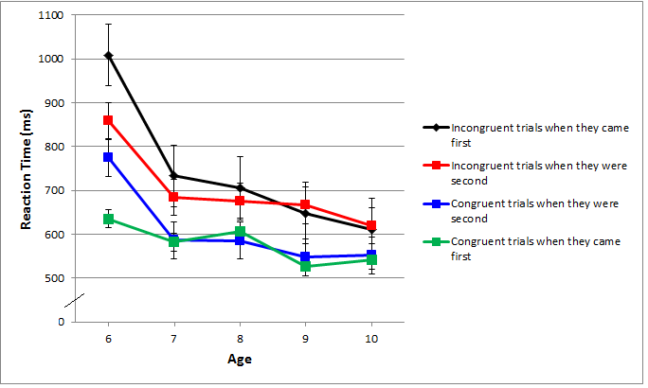

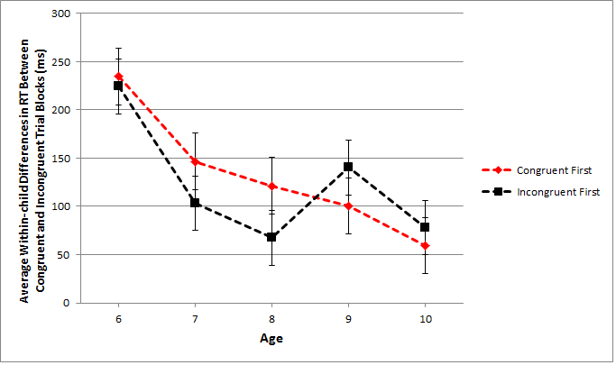

Figure 2b. Within-child difference in speed of responding on congruent and incongruent trials by order of presentation averaged over children of the same age.

Figure 2a. Speed of responding on the congruent and incongruent blocks by order of presentation

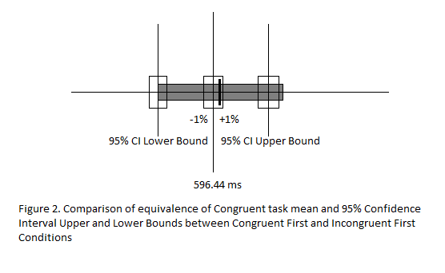

Figue 3a. 95% confidence interval around the mean RT for the congruent block when it came first is shown by the unfilled boxes. The thick line and gray box indicate the mean and 95% confidence interval for congruent trials when they came second.

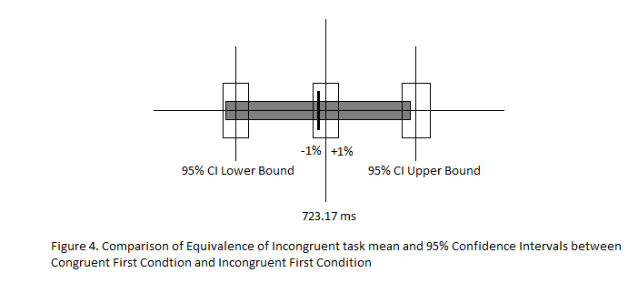

Figure 3b. 95% confidence interval around the mean RT for the incongruent block when it came first is shown by the unfilled boxes. The thick line and gray box indicate the mean and 95% confidence interval for incongruent trials when they came second.

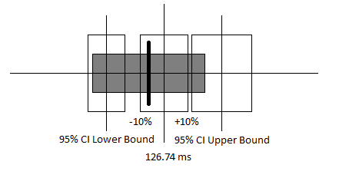

Figure 3c. 95% confidence intervals around the mean RT for the differences between the congruent and incongruent blocks when the congruent block came first is shown by the unfilled boxes. The thick line and grey box indicate the mean and 95% confidence interval for the difference between the congruent and incongruent blocks when the incongruent block came first.

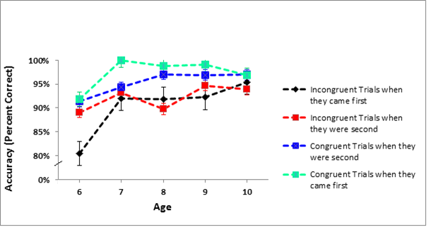

Figure 4a. Accuracy on the congruent and incongruent blocks by order of presentation

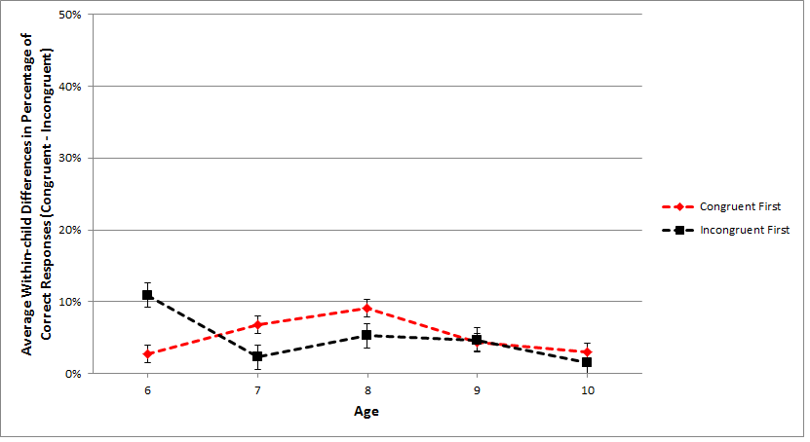

Figure 4b. Difference in accuracy between congruent and incongruent blocks by order of presentation

Figure 4b. Difference in accuracy between congruent and incongruent blocks by order of presentation

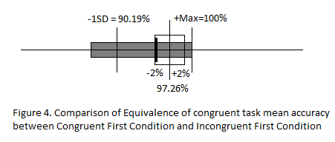

Congruent Trials when they were second

Incongruent Trials when they were second

Incongruent Trials when they came **first**

Figure 5a. 95% confidence interval around the mean accuracy for the congruent block in the congruent-first condition (unfilled boxes and solid lines) and comparison to the incongruent-first condition (solid box), plus or minus 2%

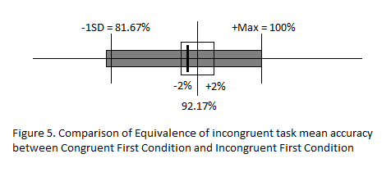

Figure 5b. 95% confidence interval around the mean accuracy for the congruent block in the congruent-first condition (unfilled boxes and solid lines) and comparison to the incongruent-first condition (solid box), plus or minus 2%

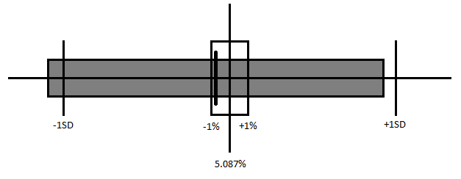

Figure 5c. 95% confidence interval around the mean difference in accuracy between congruent and incongruent blocks in congruent-first and incongruent-first conditions. Solid lines represent the accuracy difference in the congruent-first condition and the grey box represents the accuracy difference in the incongruent-first condition